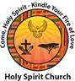 **ONLINE GIVING INSTRUCTIONS**

**General Instructions**

* To access the website, please use the web browser Google Chrome and not Internet Explorer or Microsoft

Edge.

* You need an email address to participate in the Online Giving program.
* If you do not have an email address, one can be created through a website such as “Gmail” or “Yahoo”, for

purposes of Online Giving contributions only. There are no fees associated with setting up your email.

Contact Rhonda Cross Mangham in the church office if you need assistance setting up a new email address.

**Steps**

1. Go to the Holy Spirit Church website, **http://www.holyspiritcleveland.org/** and click on the Online Giving logo.

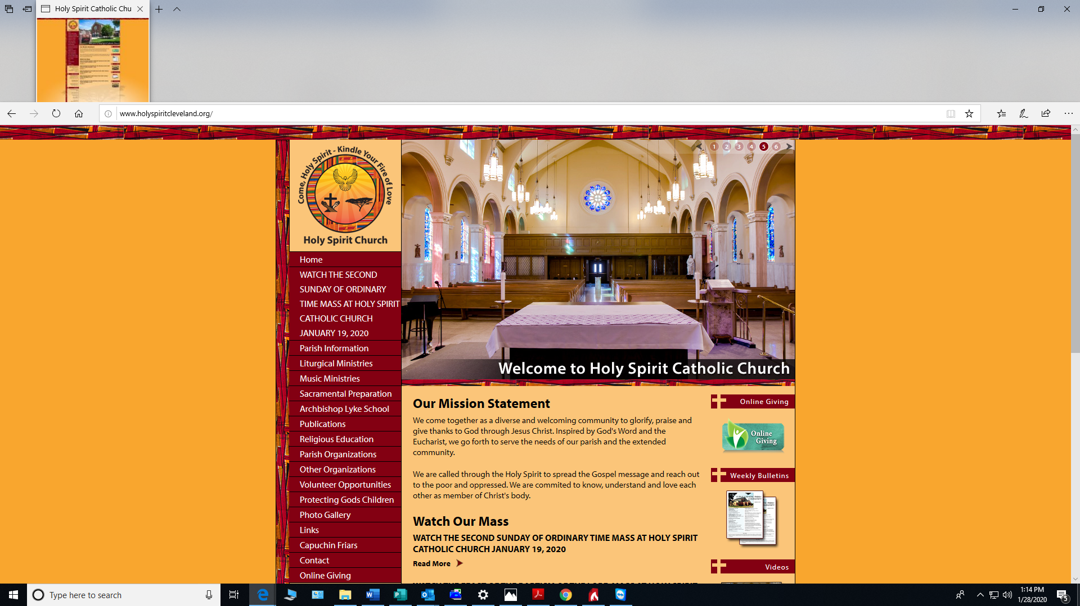

**Click on logo**

1. Select the desired fund by clicking on “Give Now”.

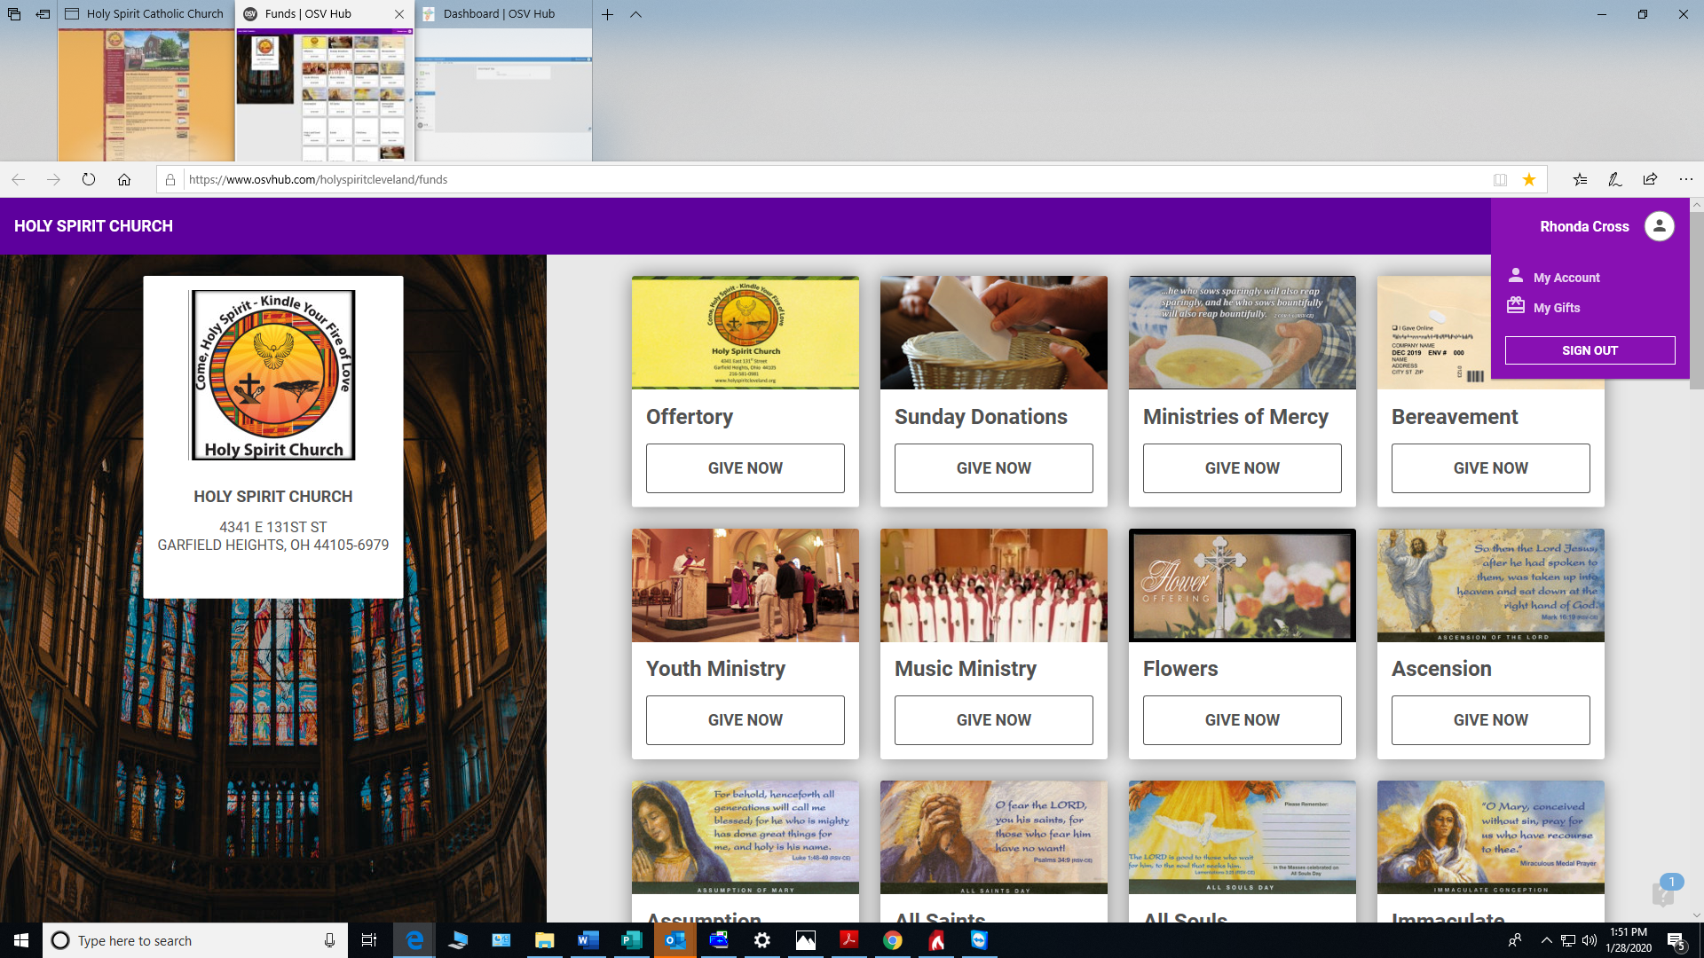

1. The “Configure Gift” screen will appear.

* Type in the amount.
* Click on the dropdown arrow for each field below and choose selection
  + *gift type - recurring or one time*
  + *frequency (for recurring only) - weekly, bi-weekly, monthly or yearly*
  + *start date - when you would like the fund contribution to begin - (use calendar icon to select date)*

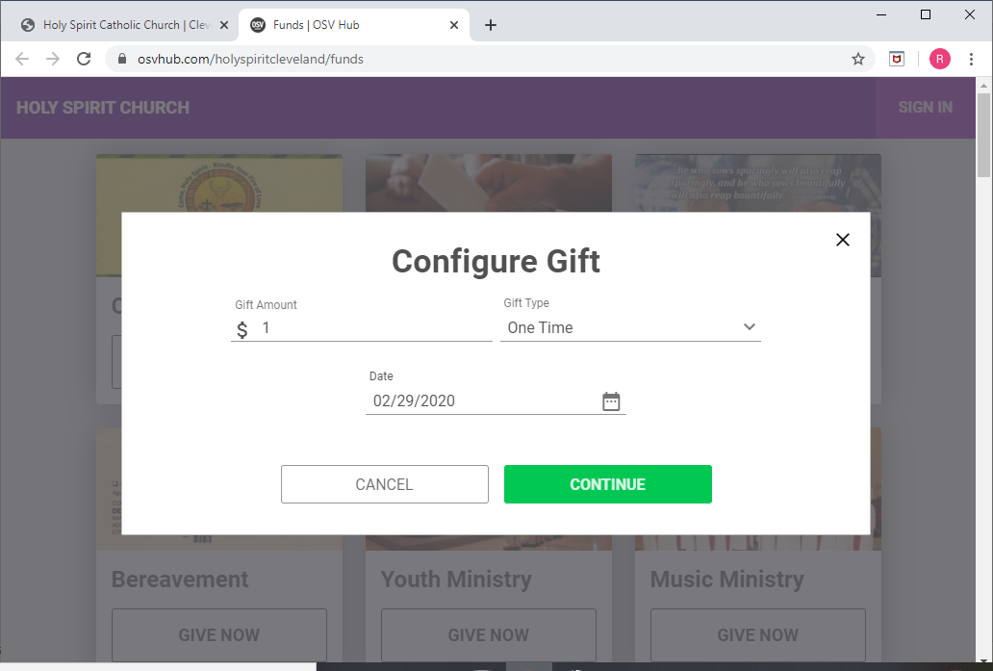

1. Select “Continue” and one of the “Your Information” screens shown in Steps 7 or 8 will appear. Complete all required fields below by typing in your:

* Email Address
* First and Last Name
* Phone Number

1. Complete the following fields on the “Your Information” screen below by clicking on the dropdown arrows for:

* Payment Type - select Bank Account or Credit Card
* For Bank Accounts - select Saving or Checking; type in the Routing Number *(checking only)* and Account Number
* For Credit Card - type in: Card Number, Expiration Month and Expiration Year
* Address - type your billing address associated with the payment account

1. If you select the date you enrolled as the date of your transaction, then the screen shown in Step 7 below will appear.
2. Click on “Save Your Information” for future contributions. If you do not select “Save Your Information”, then you will have to re-enter all of the information for future contributions and you will be submitting your gift as a “Guest”. Click “Submit Your Gift” to complete your transaction.

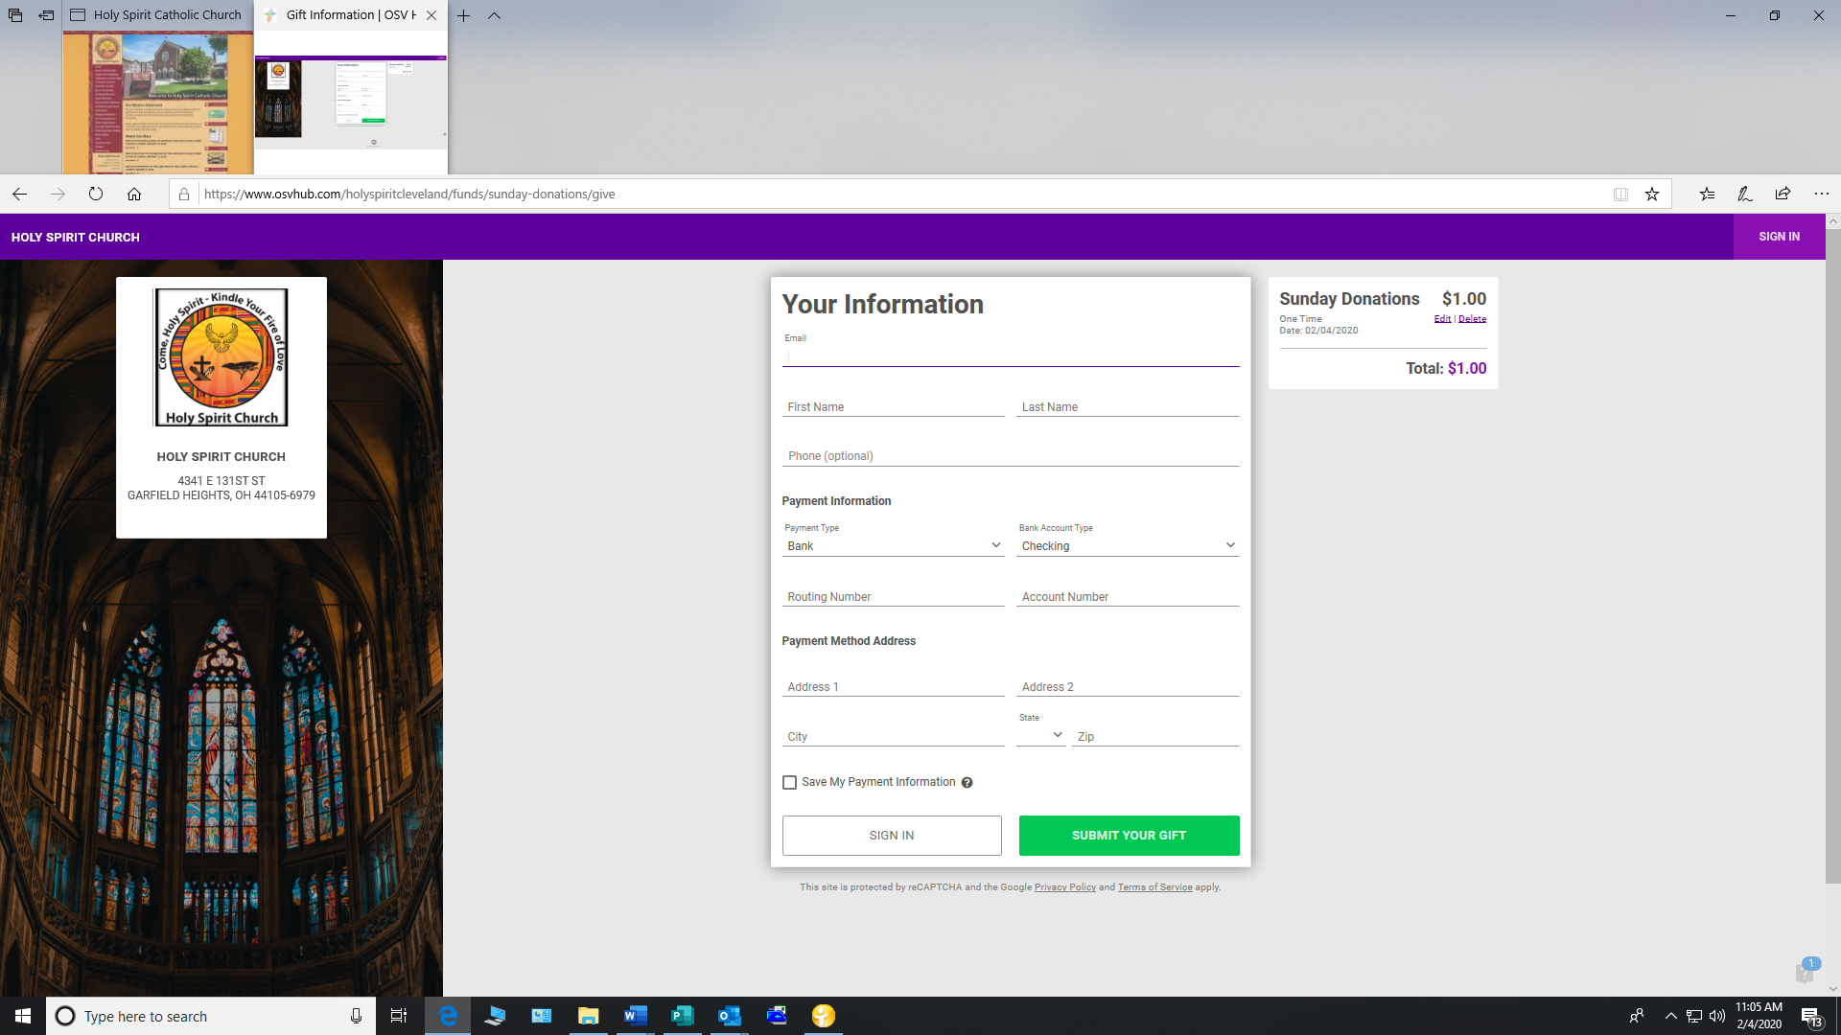

1. If you select a future date for a one-time contribution, or you select a recurring contribution, then your information will automatically be saved, and the screen below will appear. Click “Submit Your Gift” to complete your transaction.

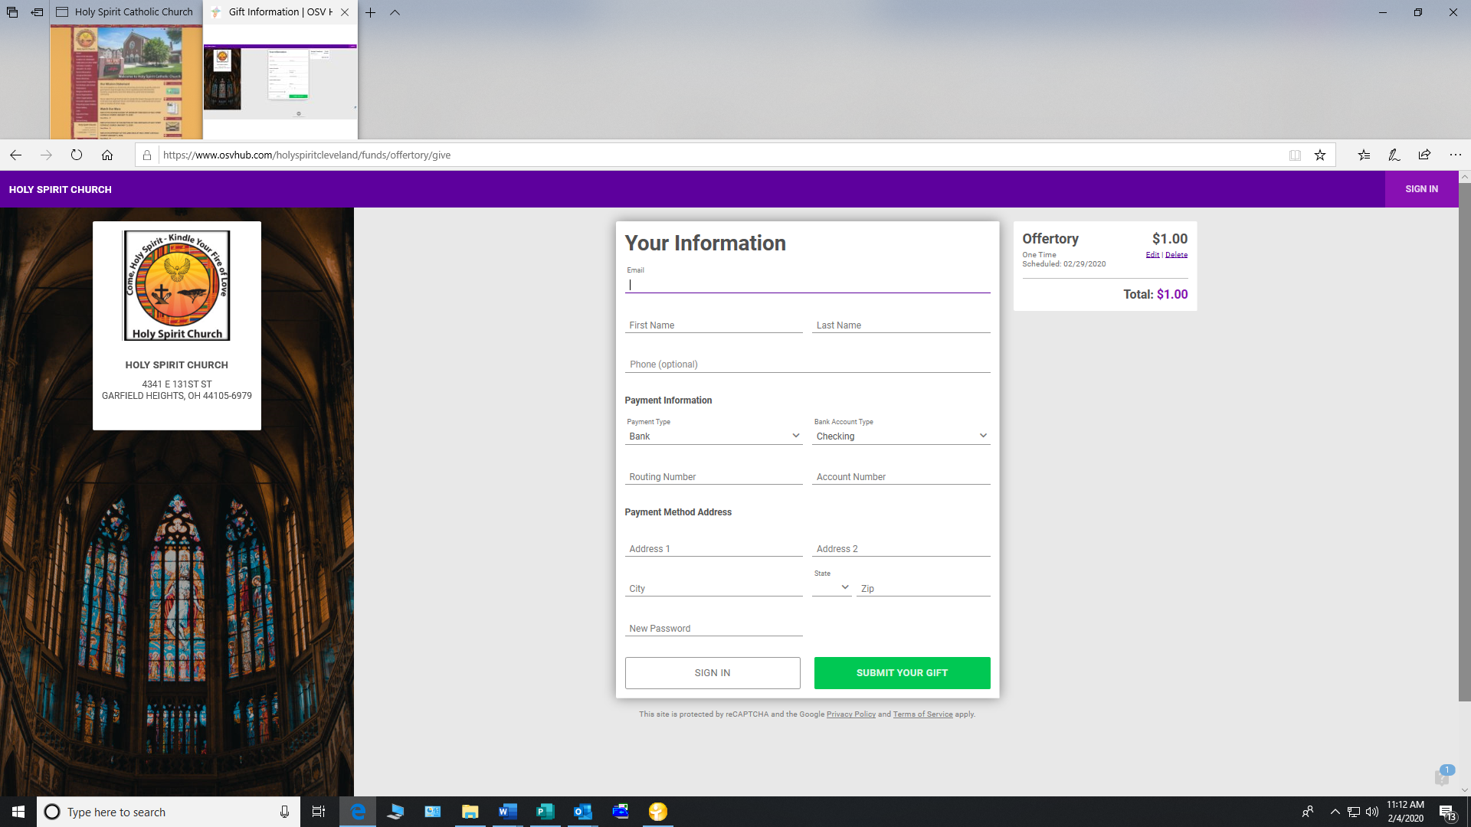

9. Once you have entered all payment information click on “Submit Gift” and the screen below will appear thanking you for your contribution. The screen will indicate it has “been processed” if it was the same day, otherwise, it will indicate it has “been scheduled”. You will also receive an email with the same information. The screen will prompt you to go back to the funds list to make additional contributions.

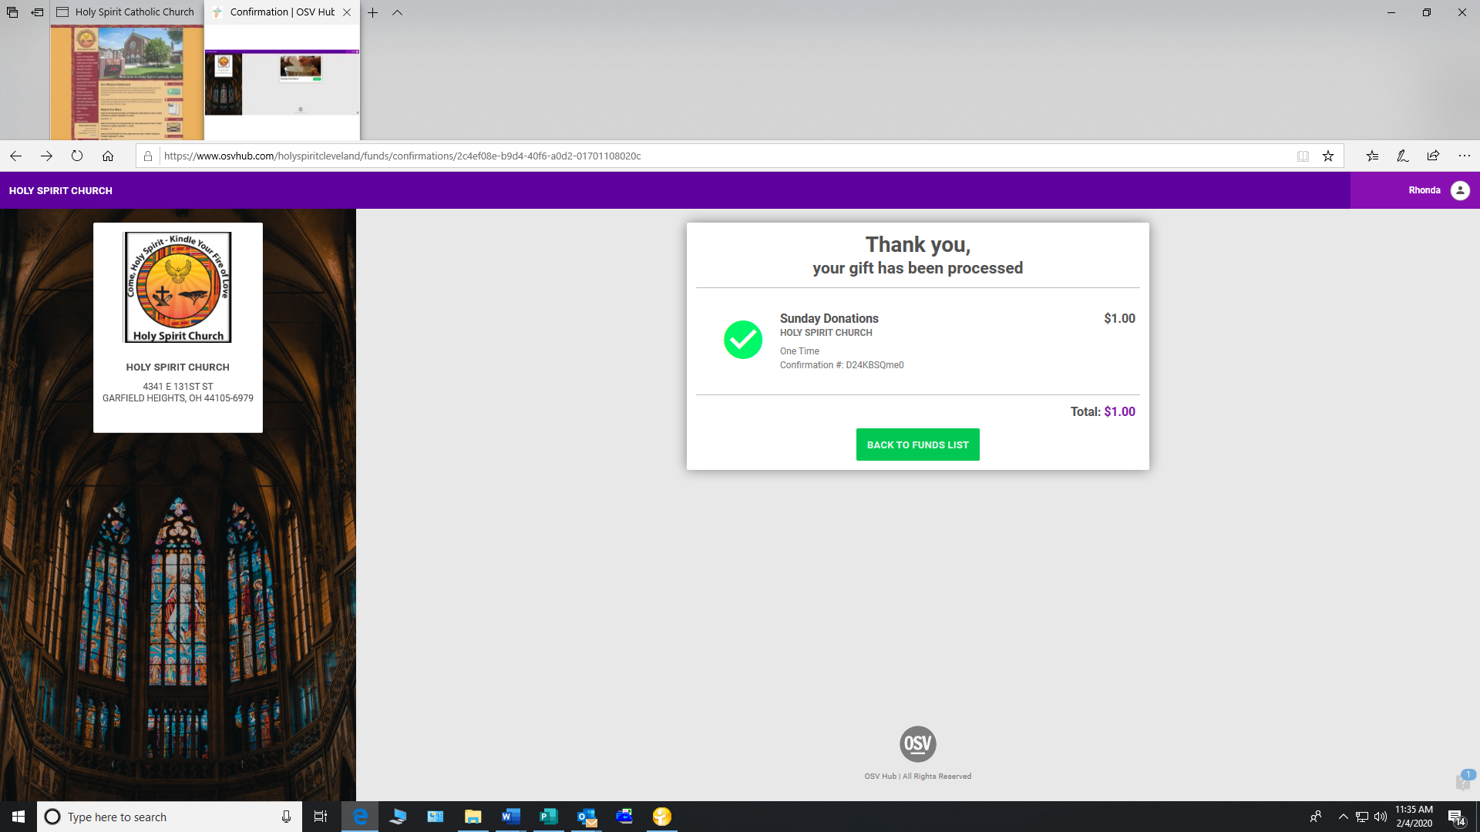

1. If you wish to edit the contribution once you click on “Complete”, you will need to contact the

Site Administrator, Rhonda Cross Mangham at 216-581-0981 to cancel the contribution. If you

have additional questions regarding the Online Giving program, please contact Mrs. Cross

Mangham. Mrs. Cross Mangham, along with Mr. Gerald Arnold our Business Manager will be

available after the Masses on an upcoming weekend for assistance.

11. Once you sign out of the website, for future contributions, access the Online Giving website and

click on “Sign-In” in the upper right-hand corner of the home screen. Then enter your username

and password.